Nexelus Configuration:

* First run the Sizmek script “new_sizmek_client_integration_ipc.sql” on IPC DB.
* In Company -> IPC Integration tab add the new record using the “Access Tag” and rest of the information just created through scripts.
  + **AdTool** – Sizmek
  + **Account ID** – 501
  + **User ID** – SizmekCampaignManagement
  + **Password** – password
  + **Access Tag** – “From the script”
  + **Ad Tool Category** – Sizmek Billing API
    - If ad tool category is not shown in the drop down, then please check the company rule “**CompanyRules/Billing/IntegrationServices/AdToolBilling**” and make sure that “Ad Serving: Sizmek” is selected.
  + Make sure the Ad Tool added is active for it to work.

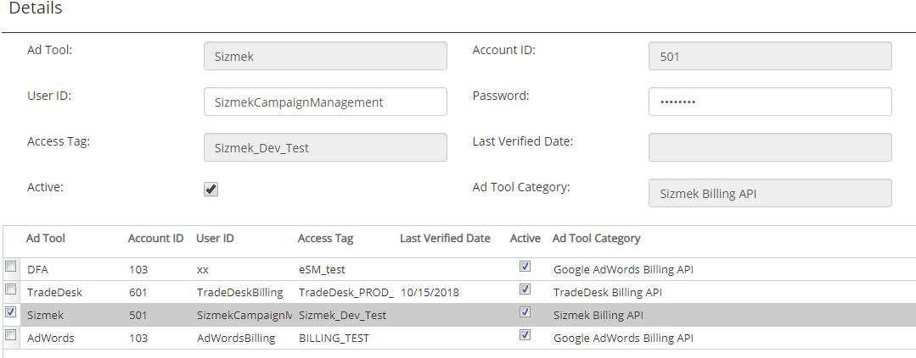

* After this setup run the script “**sizmek_nexelus_setup.sql**”.